CARIAD SE CPM Project

Functional Specification

Create PFM Versions

|  |  |
| --- | --- |
| Person Responsible: | Jimmy Xu |
| Status: | in review |
| Version: | V1.0 |
| Date: | 24/09/2025 |
|  |  |
|  |  |
|  |  |

Version History:

| Version | Date | Author | Comments |
| --- | --- | --- | --- |
| V1.0 | 24/09/2025 | Jimmy Xu |  |
|  |  |  |  |
|  |  |  |  |

# Business Purpose

As described in “Rough Estimation” process, version and version header on sub planning filed will be created. Rough estimation figures will be saved on specific versions.

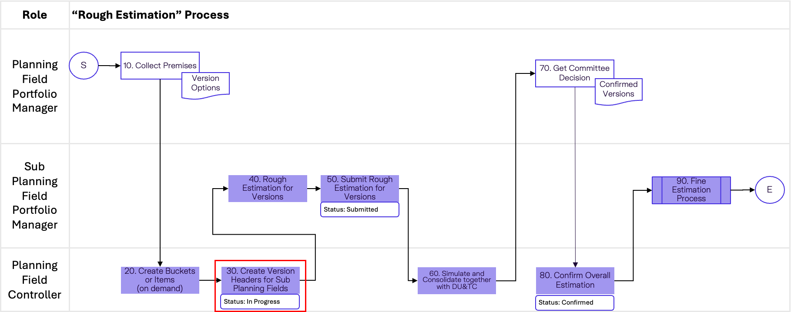

Technically, rough estimations are saved on portfolio buckets and portfolio items.

Version creation for portfolio items is standard in PFM. However, buckets do not have version function. The workaround is to create a copy of bucket structure under a dummy version portfolio.

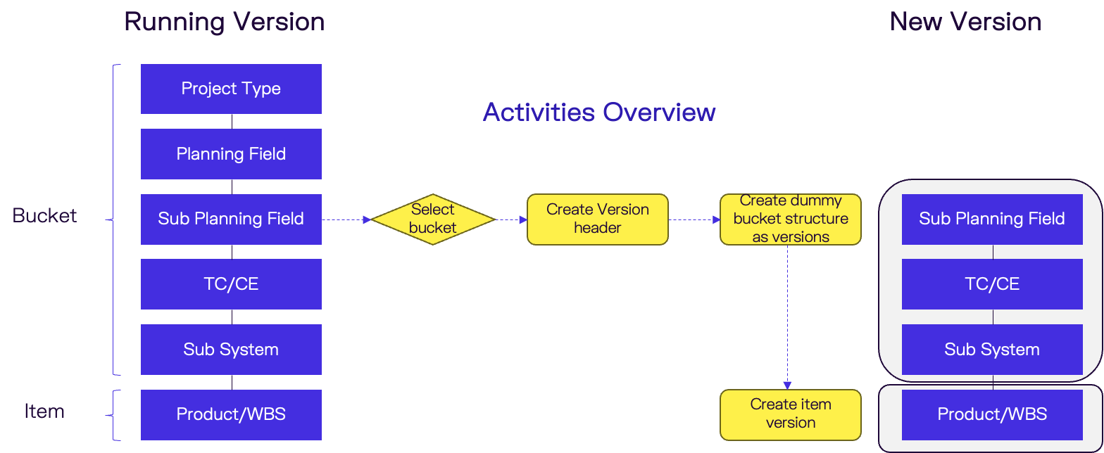

# Functional Specification

## APP and UI Overview

Functional requirement: Create versions for sub planning fields by Planning Field Product Controller on demand.

**Fiori App: Create PFM Version**

**Filter Screen:**

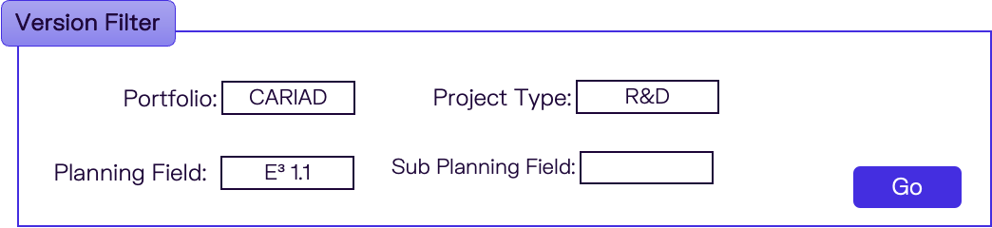

Select filter from following fields and values:

|  |  |  |
| --- | --- | --- |
| Field | Value Help | Mandatory |
| Portfolio | All portfolio master data | Yes |
| Project Type | Item types assigned under portfolio type from view /RPM/V_PORT_ITM | Yes |
| Planning Field | Planning field master data from view ZCON_CPMV_PLFLD | Yes |
| Sub Planning Field | Sub planning field master data from view ZCON_CPMV_SUBPF | No |

**Versions Screen:**

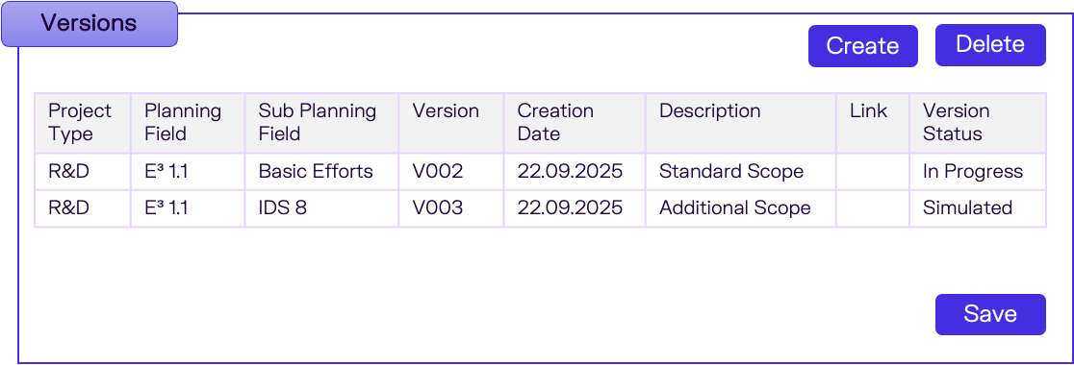

Display table for version headers from input filters.

**Button: Create**

Add new rows for following columns:

|  |  |  |
| --- | --- | --- |
| Column | Comment | Mandatory |
| Project Type | Dropdown selection:  Item types assigned under portfolio type from view /RPM/V_PORT_ITM | Yes |
| Planning Field | Dropdown selection:  Planning field master data from view ZCON_CPMV_PLFLD | Yes |
| Sub Planning Field | Dropdown selection:  Sub planning field master data from view ZCON_CPMV_SUBPF | Yes |
| Version ID | Input text. | Yes |
| Description | Input text. | Yes |
| Link | Input text. | No |
| Version Status | Display. | No |

**Button: Delete**

Delete rows from table.

**Button: Save**

Save version creation or deletion to backend.

Set Version Status to “In Progress” during creation.

Refresh version table after saving.

## Technic Prerequisite

### Version Header Table

Create a new table to save version header information.

|  |  |  |
| --- | --- | --- |
| Column | Key | Data Type |
| Object Type | Yes | CHAR, 3 |
| Object GUID | Yes | RAW, 16 |
| Version ID | Yes | CHAR, 24 |
| Description | No | CHAR, 100 |
| Link | No | CHAR, 100 |
| Version Status | No | CHAR, 4 |
| Created On | No | DATS, 8 |
| Created By | No | CHAR, 12 |
| Changed On | No | DATS, 8 |
| Changed By | No | CHAR, 12 |

### Field Extension on Bucket

Extend following fields to bucket master data table /RPM/BUCKET_D.

|  |  |  |
| --- | --- | --- |
| Column | Key | Data Type |
| Version ID |  | CHAR, 24 |
| Mirror Object GUID |  | RAW, 16 |

## Display Version Header

Get Bucket GUIDs for Sub Planning Fields from input filter

1. Load bucket structure from level 1 to level 4 by importing filter “Portfolio” ID.
2. Input filter “Project Type” ID to 2nd level bucket external ID.
3. Input filter “Planning Field” ID to 3rd level bucket external ID.
4. Input filter “Sub Planning Field” ID to 4th level bucket external ID.
5. Get all bucket GUIDs for level 4 buckets.

Get version headers

1. Import all bucket GUIDs to version header table, filed Object GUID.
2. Get following table as output.

|  |  |
| --- | --- |
| Column | Comment |
| Project Type | 2nd level bucket External ID & Name |
| Planning Field | 3rd level bucket External ID & Name |
| Sub Planning Field | 4th level bucket External ID & Name |
| Version ID |  |
| Description |  |
| Link |  |
| Version Status | ID & Name  Get Name from /RPM/V_STATUS |
| Created On |  |
| Created By | User ID & Name |
| Changed On |  |
| Changed By | User ID & Name |

## Create Version

Following steps are to be carried out when creating version.

1. Create Version Header
2. Create Buckets and Bucket Structure for versioning
3. Create Item Versions

### Create Version Header

Write following information to version header table:

|  |  |
| --- | --- |
| Column | Comment |
| Object Type | Set to “RBH” |
| Object GUID | Sub Planning Field’s Bucket GUID |
| Version ID | Input from UI |
| Description | Input from UI |
| Link | Input from UI |
| Version Status | Set to “ZES01 – In Progress” |
| Created On | Current Date |
| Created By | Current User |
| Changed On |  |
| Changed By |  |

### Create Buckets and Structure

For each sub planning field bucket, perform the following step:

1. Load all the sub buckets and bucket structure as source.
2. Create versioning buckets by coping source sub planning field bucket and all sub buckets.  
   Copy financial plan and capacity plan data together with bucket master data.  
   Write Version ID and source bucket GUID to the new buckets. Field Version ID and Mirror Object GUID.
3. Create versioning bucket structure for sub planning filed by copy original structure.
4. Get versioning dummy buckets for parent planning fields.  
   Import source planning field bucket GUID to bucket master data table /RPM/BUCKET_D – Mirror Object GUID, get dummy buckets for planning fields.
5. Assign versioning buckets for sub planning fields and version dummy buckets for planning fields.

### Create Item Version

For each portfolio item, perform the following steps:

1. Get parent bucket and its versioning bucket.
2. Create portfolio item simulation version by importing Version ID.
3. Set versioning bucket in step 1 as item version’s parent bucket.

## Delete Version

# Authorization

NA

# Others